Name: ______________ IPAD # ________

Topic #12

PHYSICAL AND CHEMICAL

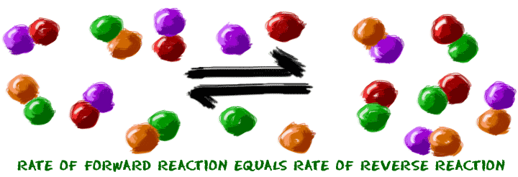EQUILIBRIUM

TEXTBOOK: CHAPTER 18

HOMEWORK PACKET DUE: __________________

ONE-DAY EXAM: ____________________

Looking Ahead:

Quarterly Exam- Free Response: __________________

Quarterly Exam Multiple Choice: _________________

**STUDENT OUTLINE AND STUDY GUIDE:**

**I. WHAT IS EQUILIBRIUM?**

Dynamic equilibrium occurs when the rate of the forward reactions EQUALS the rate of the reverse reaction. Reverse reactions are noted with a double-headed arrow.

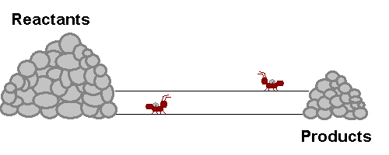

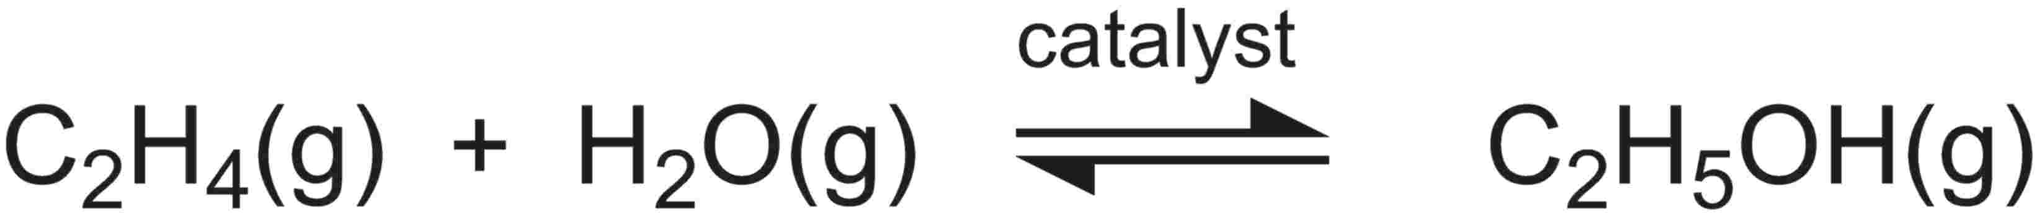

The sign that equilibrium has been reached is that the amounts/concentrations of reactants and products are constant NOT necessarily equal. In order to reach equilibrium, the reactants and products must be in a closed system or container otherwise substances may escape.

EQUAL RATES CONSTANT CONCENTRATION

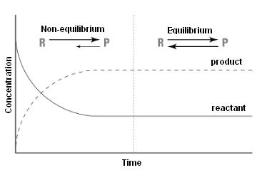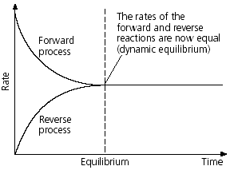

**II. TYPES OF EQUILIBRIA IN A CLOSED SYSTEM:**

**1. PHASE EQUILIBRIUM**

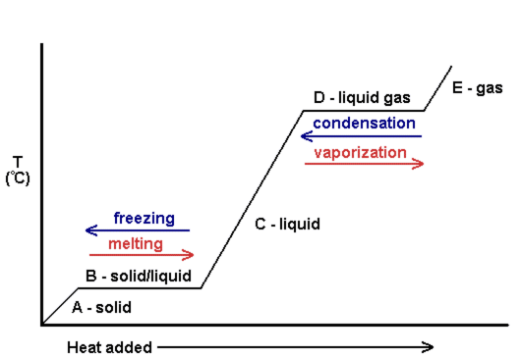

a. Equilibrium is reached when the rate of melting equals the rate of freezing at the melting point/freezing point temperature.

b. Equilibrium is reached when the rate of vaporization equals the rate of condensation at the boiling point/condensation point temperature.

**2. SOLUTION EQUILIBRIUM**

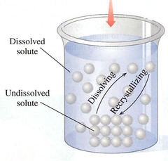 Equilibrium is reached when the rate of dissolving equals the rate of crystallization in a **SATURATED** solution.

**NaCl(s) <-> Na+(aq) + Cl-(aq)**

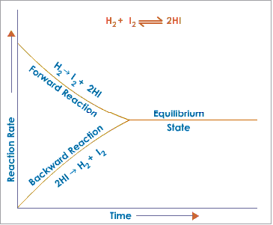

**3. CHEMICAL EQULIBRIUM**

The rate of synthesis of hydrogen iodide

from its elements equals the rate of

decomposition of hydrogen iodide into its

elements.

**III. LAW OF CHEMICAL EQUILIBRIUM**

A reaction at equilibrium can be represented by the following equation:

aA + bB <----> cC + dD

*Note: small letters represent coefficients in a balanced equation and the capital letters represent chemical formulas in a reaction.*

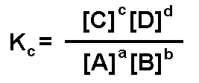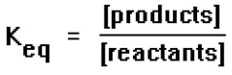

**The rules from converting from converting a chemical equation into a mathematical equation are:**

1. [products] / [reactants]

2. brackets means “concentration of”

3. Coefficients (moles) become exponents

4. do not include solids or pure liquids in the equilibrium expression

**The Keq value measures the extent of the reaction.**

A **large K** value indicates a reaction that favors **products** (shift right)

A **small K** value indicates a reaction that favors **reactan**ts (shift left)

**IV. LeChatelier’s Principle:**

If a system at equilibrium is subject to **stress**, the system will shift so that the stress is relieved. The shift will result in a net increase or decrease in the substances of the system.

*A **shift right** will cause an **increase** in **products** and **decrease** in **reactants**.

**A **shift left** will cause a **decrease** in **products** and **increase** in **reactants**

A stress on a system is any factor that can affect the rate of a chemical change. In topic #8, Kinetics (Chapter 18), we studied the factors that can affect the rate of a chemical reaction or physical change. These factors are temperature, pressure (gases only!), concentration, surface area of a solid, and a catalyst. These factors are the same stresses that can cause a reversible reaction to shift more to the right or left.

**Summary of Chemical Stresses on Equilibrium**

|  |  |
| --- | --- |
| **STRESS** | **AFFECT** |
| **TEMPERATURE** | * **Increase** temperature favors an **endothermic** reaction * **Decrease** temperature favors an **exothermic** reaction |
| **PRESSURE** | * **Increase pressur**e favors the direction of the reaction that produces **less moles** of gas. * **Decrease** **pressu**re favors the direction of the reaction that produces **more moles** of gas. |
| **CONCENTRATION** | * **Increase concentration** of one   substance in a system favors the direction of the reaction that **reduces** the excess amount.   * **Decrease concentration** of one   substance in a system favors the direction of the reaction that **replaces** the missing substance. |
| **COMMON ION EFFECT**  ***Solution Equilibrium*** | * Increase concentration of an ion favors crystallization and a decrease in solubility of the salt. * Decrease concentration of an ion favors dissolving and an increase in solubility of the salt. |
| **CATALYST** | Adding a catalyst affects opposing reactions equally; no net change in equilibrium or the value of Keq. Equilibrium is reached more quickly. **NO SHIFT!!** |

**HOMEWORK PACKET**

**Part I-WHAT IS EQUILIBRIUM?**

Using the glossary in the textbook, define the following terms:

**Chemical reaction:** ______________________________________________________________________________________________________________________________________________________________________________________________________

**Chemical Equilibrium:**

______________________________________________________________________________________________________________________________________________________________________________________________________

**Page 610**

**INTERPRET GRAPHS-**FIGURE 18.13

a. __________________________________________________________________________

_______________________________________________________________

b. ___________

c. _______________________________________________________________

_______________________________________________________________

**Page 620**

#25_________________________________________________________________________

**Page 638**

#63 __________________________________________________________________________

_______________________________________________________________

**Part II-TYPES OF EQUILIBRIA IN A CLOSED SYSTEM**

**Write a balanced equation that represents each type of equilibrium. Search using the Internet, textbook or class notes for appropriate examples.** \****Do not use examples listed in the study guide.***

|  |  |
| --- | --- |
| **Type of Equilibrium** | **Balanced Equation** |
| **Phase Equilibrium** |  |
| **Solution Equilibrium** |  |
| **Chemical Equilibrium** |  |

**Part III LAW OF CHEMICAL EQUILIBRIUM**

Using the glossary in the textbook, define the following term:

**Equilibrium Constant (Keq):**

______________________________________________________________________________________________________________________________________________________________________________________________________

**Page 620**

#27 _________________________________________________________________________

_________________________________________________________________________

#30 __________________

**Extent of the reaction: Fill in the chart below with either “high/relatively large number” or “low/relatively small number”**

|  |  |  |
| --- | --- | --- |
| **Keq** | **Equilibrium concentrations or moles of reactants** | **Equilibrium concentrations or moles of products** |
| **Relatively large**  **K>10** |  |  |
| **Relatively small**  **K<0.1** |  |  |

**Page 617-618**

|  |  |
| --- | --- |
| #19 | #21 |
| #20 | #22 |

**Page 638**

#66 a. b.

#67 a. ____________________ b. ____________________ c. ____________________

#90

#91 (Include equilibrium expression for this reaction)

**Part IV LeChatelier’s Principle**

Using the glossary in the textbook, define the following term:

**Le Chatelier’s Principle:**

______________________________________________________________________________________________________________________________________________________________________________________________________

**Page 620**

#26 _____________________________

_____________________________

_____________________________

#28 _________________________________________________________________________

_________________________________________________________________________

#32 _________________________________________________________________________

_________________________________________________________________________

**Page 615**

#17 a. ______________________________

b. ______________________________

c. ______________________________

d. ______________________________

#18 a. ______________________________

b. ______________________________

c. ______________________________

d. ______________________________

**Page 626**

#37 _________________________________________________________________________

#39

#45 _________________________________________________________________________

_________________________________________________________________________

**Page 638 – 639**

#70 a. b.

# 71 ______ _______ _______ _______

#72 __________________________________________________________________________

__________________________________________________________________________

#82 __________________________________________________________________________

__________________________________________________________________________

**Pearsons SuccessNet On-line**

**The Chemistry of Diabetes**

Understand Diabetes by watching the video online.

1. Complete the following reaction:

glucose + protein <---> __________________

2. How is Le Chatelier’s principle used to control diabetes?

**________________________________________________________________**

**__________________________________________________________________**

**Complete the following chart by writing left, right or none for “equilibrium shift” and decreases, increases or remains the same for the “concentrations” of reactants and products and for the value of K.**

**Synthesis of Hydrogen Iodide**

**H2(g)  + I2(g) + 52.7 kJ <-----> 2HI(g)**

|  |  |  |  |  |  |
| --- | --- | --- | --- | --- | --- |
| **Stress** | **Equilibrium**  **Shift** | **[H2]** | **[I2]** | **[HI]** | **K value** |
| **Add H2** |  |  |  |  |  |
| **Add I2** |  |  |  |  |  |
| **Add HI** |  |  |  |  |  |
| **Remove H2** |  |  |  |  |  |
| **Remove I2** |  |  |  |  |  |
| **Remove HI** |  |  |  |  |  |
| **Increase**  **Temperature** |  |  |  |  |  |
| **Decrease**  **Temperature** |  |  |  |  |  |
| **Increase**  **Pressure** |  |  |  |  |  |
| **Decrease**  **Pressure** |  |  |  |  |  |

Macintosh HD:Users:alicezagelbaum:Desktop:chemmatters-sept2005-equilibrium.pdf





Answer the following questions related to the article “What’s So Equal About Equilibrium?”

1. Describe the two things that are happening that describe the “dynamic equilibrium” involving chlorine within a fish tank.

________________________________________________________________________________________________________________________________________________________________________________________________________________________________________________________________________

2. Why is the reaction of hydrogen and oxygen to form water written as a completion reaction with a single arrow?

____________________________________________________________________________________________________________________________________

3. Why is the reaction of hydrogen and nitrogen to form ammonia always written as a reversible reaction with a double arrow?

____________________________________________________________________________________________________________________________________

3. What is the function of the earth’s ozone layer?

______________________________________________________________________________________________________________________________________________________________________________________________________

4. What creates ozone in the stratosphere?

____________________________________________________________________________________________________________________________________

5. Name two catalysts that break ozone down in the stratosphere.

__________________________________________________________________